Jesus Nolazco

Chapter 1 – Assignment 01-1

10/4/21

Try This 1-1

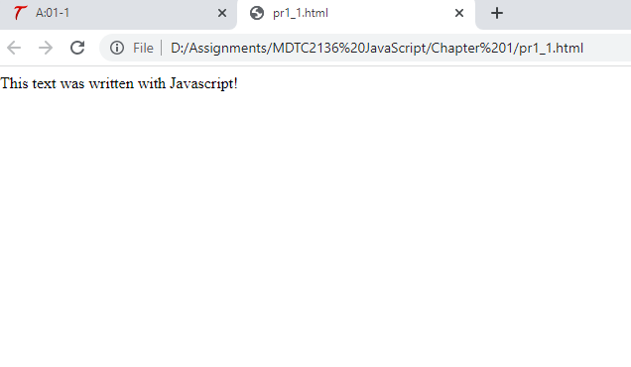

<html>

    <body>

        <script>

            document.write("This text was written with Javascript!")

        </script>

    </body>

</html>